15th January 2014

**YOKOHAMA Champion Nash visits Autosport**

WTCC Driver James Nash, new WTCC YOKOHAMA Trophy winner was a guest at the YOKOHAMA booth at the Autosport International Show in Birmingham over the past weekend.

The “independent” Champion and overall 3rd qualified at the last season’s World Touring Car Championship took the opportunity to visit the Japanese Tyre manufacturer’s UK Distributor’s booth where he also had a chance to meet representatives of Yokohama HPT Ltd., YOKOHAMA´s UK based subsidiary and representatives of Yokohama Europe GmbH.

Commenting on the visit of James Nash, David Oliva responsible for YOKOHAMA Europe communications expressed delight at the fact that James had taken his time to visit the YOKOHAMA booth and highlighted the superb season James had. “We are very happy to welcome James after such a splendid season and it is also special that he brought the YOKOHAMA Trophy with him to show our visitors.”

Throughout the Autosport show, a number of leading international drivers and champions in the many different Motorsports categories, ranging from F1 to the World Touring Car Championship attended, signed autographs for fans and gave their first hand views and opinions of the last season and their hopes and aspirations for the near future to the media.

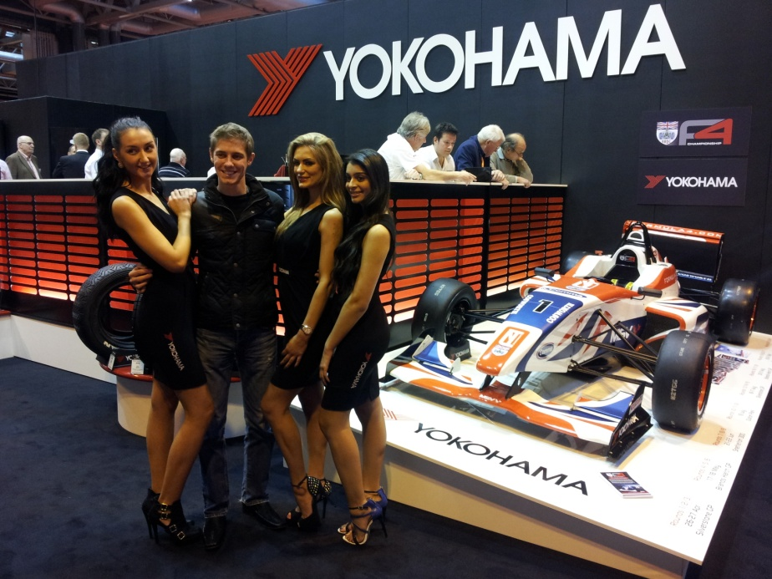

James Nash and the YOKOHAMA Ladies